1. There is no connection b/w SSL, TLS and Certificate.
2. A certificate can be used for SSL and TLS.
3. 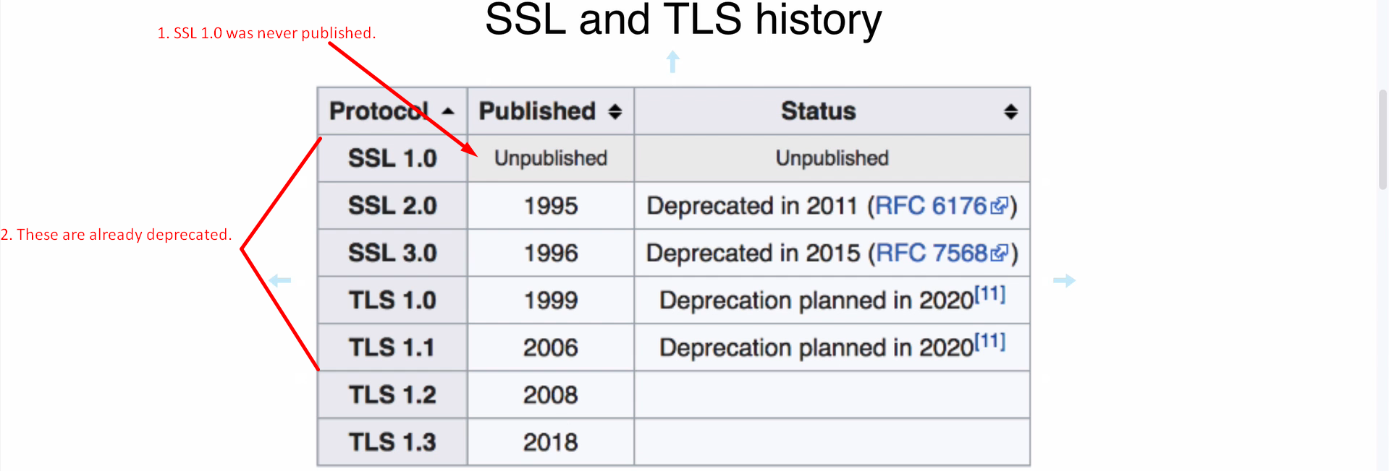
4. 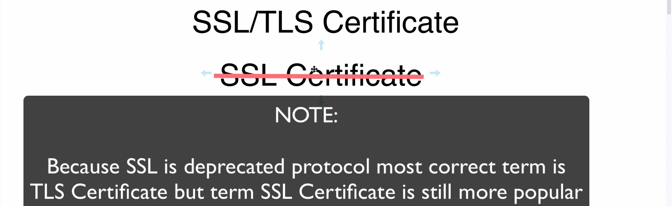  
   
5. 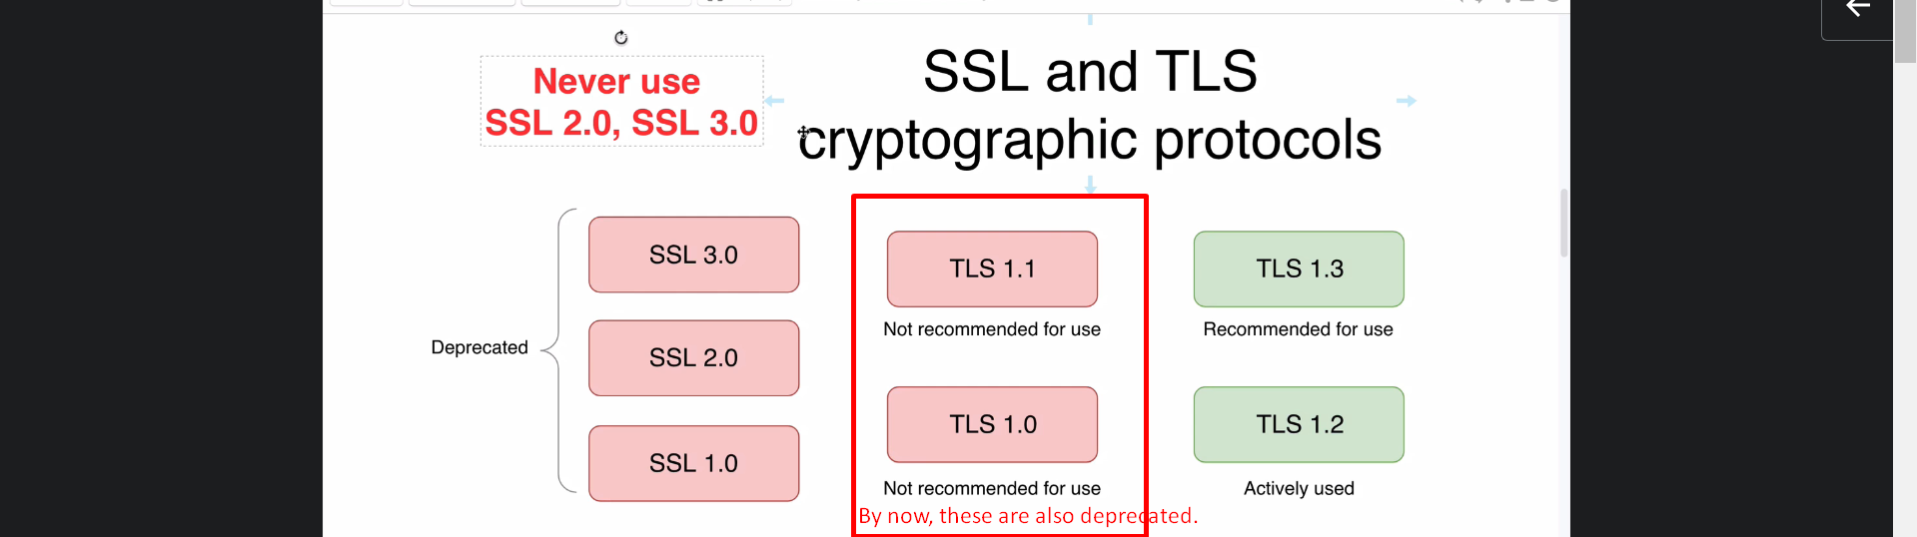
6. 